How to trim your edTPA video with iMovie
- Open iMovie, and press the “Import” button to load your video. | 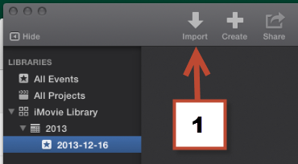
- Navigate to the video, click on it, and click the “Import Selected” button. | 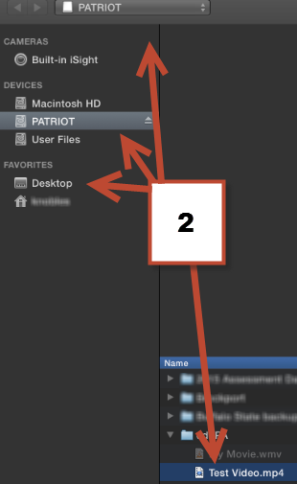  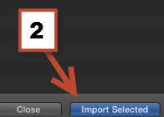

- A filmstrip of the video will appear in the bottom portion of the screen. Hover your mouse cursor over the filmstrip where you want the video to begin. Then, click and drag your mouse cursor to where you want the video to end. A yellow bar will outline the clip you just selected. | 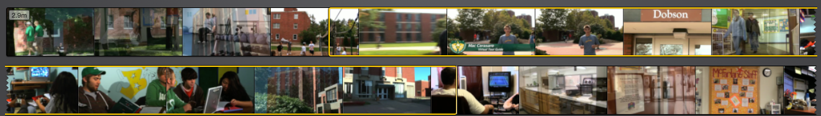
- When you have the clip selected and are ready to save it, click on the “Share” button, and then select the “File” option | 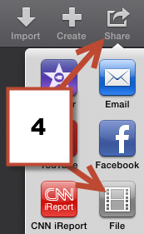
- Click “Next” | 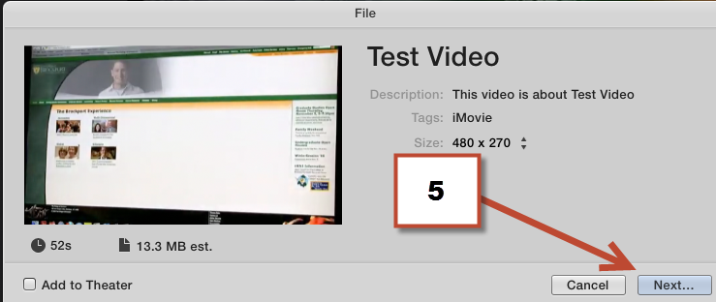
- Enter the title of the new file in the “Save As” box. In the “Where” dropbown box, select where you’d like the new file to be saved. Click the “Save” button. | 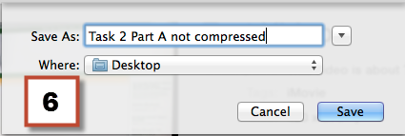
- Toward the top right corner of the program, a small blue icon will appear that represents that the file is saving. When the blue icon is a complete circle, the file is done saving, and you may close the program. | 

